

**EAST WEST UNIVERSITY**

**Course Title:** Signals and Systems

**Course Code:** CSE248

**Section No:** 2

**Project Report**

**Submitted To:**

Waselul Haque Sadid, PhD

Assistant Professor,

Department of Computer Science and Engineering,

East West University.

**Submitted By:**

Shaykh Siddique

ID: 2016-1-60-053

Noor-E-Jannat

ID: 2016-1-60-067

JannatulNaym

ID: 2016-1-60-119

**Introduction:**

A signal is an electrical or electromagnetic current that is used for carrying data from one system or network to another.According to Alan V. Oppenheim and Ronald W. Schafer, the principles of signal processing can be found in the classical numerical analysis techniques of the 17th century. The application fields of signal processing can be defined **audio signal processing, digital signal processing, speech signal processing, image processing, video processing, wireless communication, control systems, array processing, array processing, seismology, genomics and so on.**

1. **Periodical Signal -** A signal that repeats its pattern over a period is called periodic signal
2. **Aperiodical Signal -** A signal that does not repeats its pattern over a period is called aperiodic signal or non-periodic signal.

**Mathematical expression of a signal:**

Asignal can be express a mathematical format. Let define, function x(t) as a signal.

(-t)-3, -5 ≤ t ≤ -3

0, -3 < t ≤ -2

x(t) = 1, -2 < t ≤ 0

t+1, 0 < t ≤ 1

0, otherwise

**Graphical representation of a signal using Matlab:**

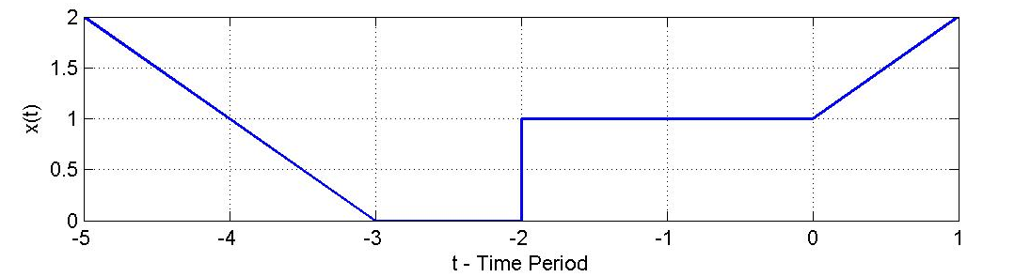

**Operations on signal:**

**Time shifting operation:** The original signal is x(t), then x(t + t0) will be the shifted version of x(t).

Let t0 = 2 then,

(-t)-5, -7 ≤ t ≤ -5

0, -5 < t ≤ -4

x(t+2)= 1, -4 < t ≤ -2

t+3, -2 < t ≤ -1

0, otherwise

Graphical representation of x(t):



Graphical representation of x(t+2):

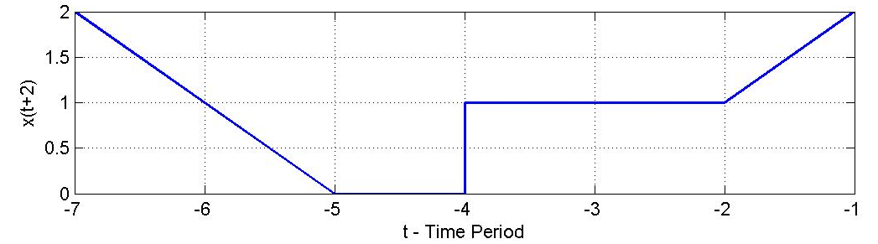

If t0 = -2 then,

(-t)-1 , -3 ≤ t ≤ -1

0, -1 < t ≤ 0

x(t-2)= 1, 0 < t ≤ 2

t+3, 2 < t ≤ 3

0, otherwise

Graphical representation of x(t-2):

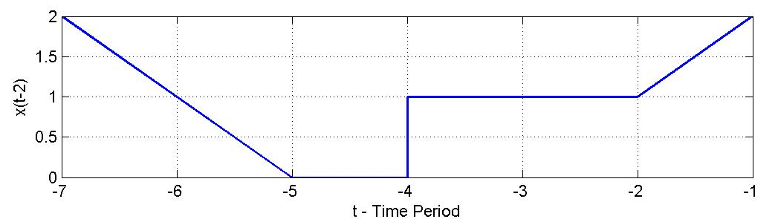

**Reflection:** The original signal is x(t), then x(-t) will be the reflected version of x(t).

(-t)-3, -5 ≤ t ≤ -4

1, -4 < t ≤ -2

x(- t)= 0, -2 < t ≤ -1

t+1, -1 < t ≤ 1

0, otherwise

Graphical representation of x(-t):

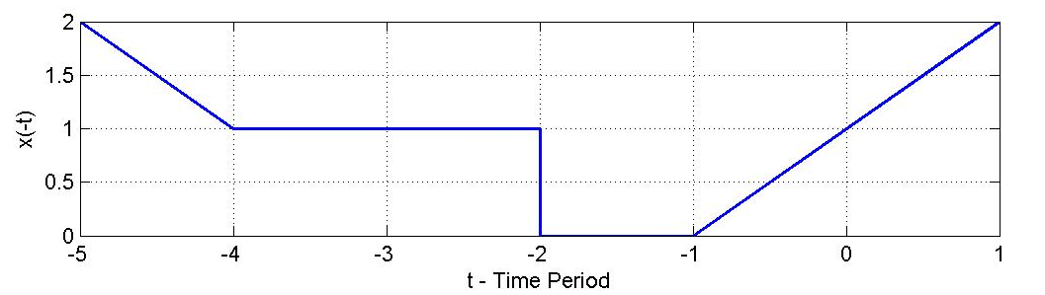

**Time scaling operation:**

x( ɳ t ) is the scaled version of x(t) where,

* $\left| ɳ \right|$ > 1 compressed version.
* $\left| ɳ \right|$ < 1 expanded version.

Let $ɳ$ = 2 then,

(-2t)-3 , -5/2 ≤ t ≤ -3/2

0, -3/2 < t ≤ -1

x(2t)= 1, -1 < t ≤ 0

2t+1, 0 < t ≤ 1/2

0, otherwise

Graphical representation of x(2t):

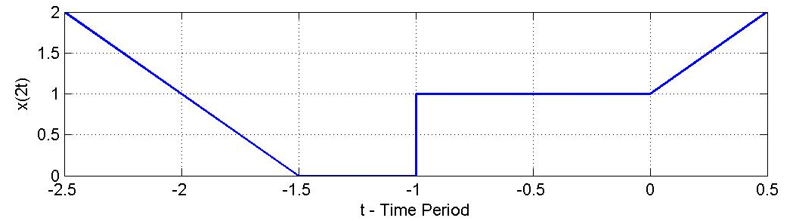

**Symmetric Properties:**

* x(t) = x(-t) then, Even symmetric signal.
* x(t) = -x(-t) then, Odd symmetric signal.

Graphical representation of even symmetric signal:

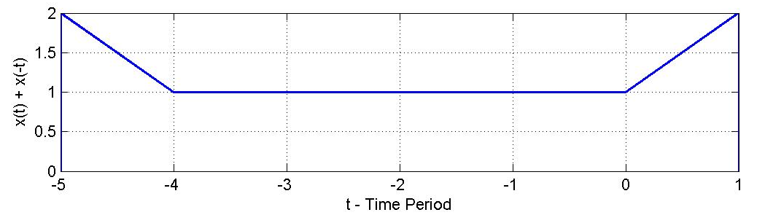

Even part- $\frac{x\left(t\right)+x(-t)}{2}$

Odd part- $\frac{x\left(t\right)-x(-t)}{2}$

Matlab Source Code:

Fig1 – x(t):

clc;

clearall;

t =[-5 -3 -2 -201];

x =[200112];

**plot**(t, x, 'blue', 'LineWidth', 1.5);

**grid**on;

**set**(**gcf**, 'Units', 'Inches', 'Position', [2, 3, 8, 2], 'PaperUnits', 'Inches', 'PaperSize', [8, 2]);

**set**(**gcf**, 'PaperUnits', 'inches');

x_width=8 ;y_width=2;

**set**(**gcf**, 'PaperPosition', [00x_widthy_width]);

**saveas**(**gcf**,'fig1Original.jpg');

Fig2 – x(t+2):

clc;

clearall;

*%t =[-5 -3 -2 -2 0 1]; t will be shifted to t0*

t0 = [-7 -5 -4 -4 -2 -1];

x =[200112];

**plot**(t0, x, 'blue', 'LineWidth', 1.5);

**grid**on;

**set**(**gcf**, 'Units', 'Inches', 'Position', [2, 3, 8, 2], 'PaperUnits', 'Inches', 'PaperSize', [8, 2]);

**set**(**gcf**, 'PaperUnits', 'inches');

x_width=8 ;y_width=2;

**set**(**gcf**, 'PaperPosition', [00x_widthy_width]);

**saveas**(**gcf**,'fig2_shift_right.jpg');

Fig2 – x(t-2):

clc;

clearall;

*%t =[-5 -3 -2 -2 0 1]; t will be shifted to t0*

t0 = [-3 -1 -0 -023];

x =[200112];

**plot**(t0, x, 'blue', 'LineWidth', 1.5);

**grid**on;

**set**(**gcf**, 'Units', 'Inches', 'Position', [2, 3, 8, 2], 'PaperUnits', 'Inches', 'PaperSize', [8, 2]);

**set**(**gcf**, 'PaperUnits', 'inches');

x_width=8 ;y_width=2;

**set**(**gcf**, 'PaperPosition', [00x_widthy_width]);

**saveas**(**gcf**,'fig2_shift_left.jpg');

Fig3 – x(-t):

clc;

clearall;

t0 = [1 -1 -2 -2 -4 -5];

x =[200112];

**plot**(t0, x, 'blue', 'LineWidth', 1.5);

**grid**on;

**set**(**gcf**, 'Units', 'Inches', 'Position', [2, 3, 8, 2], 'PaperUnits', 'Inches', 'PaperSize', [8, 2]);

**set**(**gcf**, 'PaperUnits', 'inches');

x_width=8 ;y_width=2;

**set**(**gcf**, 'PaperPosition', [00x_widthy_width]);

**saveas**(**gcf**,'fig3_refl.jpg');

Fig3 – x(3t):

clc;

clearall;

t0 = [-5/2 -3/2 -1 -101/2];

x =[200112];

**plot**(t0, x, 'blue', 'LineWidth', 1.5);

**grid**on;

**set**(**gcf**, 'Units', 'Inches', 'Position', [2, 3, 8, 2], 'PaperUnits', 'Inches', 'PaperSize', [8, 2]);

**set**(**gcf**, 'PaperUnits', 'inches');

x_width=8 ;y_width=2;

**set**(**gcf**, 'PaperPosition', [00x_widthy_width]);

**saveas**(**gcf**,'fig3_scaling_com.jpg');

Fig4 symmetric signal:

clc;

clearall;

t0 = [-5 -5 -4011];

x =[021120];

**plot**(t0, x, 'blue', 'LineWidth', 1.5);

**grid**on;

**set**(**gcf**, 'Units', 'Inches', 'Position', [2, 3, 8, 2], 'PaperUnits', 'Inches', 'PaperSize', [8, 2]);

**set**(**gcf**, 'PaperUnits', 'inches');

x_width=8 ;y_width=2;

**set**(**gcf**, 'PaperPosition', [00x_widthy_width]);

**saveas**(**gcf**,'fig3_sym_even.jpg');

**Conclusion:**

We described just some of the ways in which signals can be classified and simple operations. They can be continuous time or discrete time, analog or digital, periodic or aperiodic, finite or infinite, and deterministic or random. We can also divide them based on their causality and symmetry properties. There are other ways to classify signals, such as boundedness, handedness, and continuity that are not discussed here but will be described in subsequent modules.

**References:**

<https://en.wikipedia.org/wiki/Signal_processing>

<http://iitg.vlab.co.in/?sub=59&brch=166&sim=618&cnt=1>